

St Edward’s Catholic Primary School

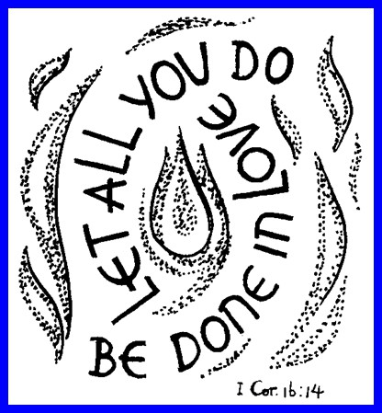

Behaviour Policy

Presented to Governor: Pending Approval

Adopted by Governors: Pending Approval Review date: March 2026

“Let All We Do Be Done in Love”
At the heart of everything we say and do at St Edward’s is the belief that all children are created and loved by God. It is because of this that they deserve the highest possible standards of teaching and learning.
St Edward’s Catholic Primary School recognises that each child is a child of God and as such have the right to feel safe and secure. The children are encouraged to talk and to be heard. Children know that they can approach any of the adults in school if they are worried and that they will receive a consistent supportive approach.
We aim to create a caring environment in which each person is valued as an individual and is encouraged to develop his/her full potential in all aspects of their life. We bring all children to an understanding that we are all members of God's family and as such we must have respect for ourselves, for other people, including their feelings and their property, and for all living things.
We also believe that all adults who are connected with the school must share the responsibility for establishing and maintaining the values that we wish to see reflected in the children's behaviour.
St Edward’s is committed to providing an ethos in which individuals are brought to a deeper knowledge and understanding of the Catholic faith within a climate that ensures an education of the highest standard.

Our policy process is supported by the Department for Education ‘Behaviour in Schools’ February 2024 to ensure our practice is up to date. Changes will be checked regularly and the policy reviewed in accordance with any changes to the advice from the Department for Education. Behaviour in Schools - Advice for headteachers and school staff Feb 2024

Our school Beatitudes that every child knows and follows are.
- Be kind
- Be good
- Be helpful
- Be a friend
- Be honest
- Be polite
- Be the best that I can be

The school teaches behaviour explicitly as part of a structured behaviour curriculum. Children are taught how to regulate their emotions, how to resolve conflict safely, how to use respectful and appropriate language, and how to build positive relationships rooted in our Catholic values. This teaching takes place through PSHE, RSE, RE, assemblies, restorative conversations and daily routines. Behaviour expectations are revisited regularly and reinforced consistently so that pupils understand not only what is expected of them, but why these expectations matter within a loving and respectful school community.

The guiding principles of our behaviour expectations:
- Experience a positive and purposeful ethos providing a sense of belonging to their school community.
- Grow in their knowledge and understanding of the beatitudes.
- Practise the beatitudes to further the call to live life to the full.
- Appreciate the connection between biblical and practical wisdom and living.
- Hear the Christian story and encounter it in practice.
- Understand their uniqueness and dignity as made in the image and likeness of God.
- Know that our limitations are also opportunities for growth.
- To notice, to reflect, to pray and to play
- To exercise the cognitive, affective and behavioural components of character: know it in your head, feel it in your heart and show it with your hands.

We have a positive and caring attitude towards each other and our environment
We welcome each and every person who joins our school community and understand that they have a personal part to play. We support each person’s talents, they will be valued and enjoyed.
We listen with care to the views and opinions of others, and we respect them.
We each fulfil our responsibilities with regard to completing tasks to the best of our abilities, taking personal responsibility for our school buildings and co-operating with other school members.
Senior Leaders will ensure through staff induction that the behaviour is shared and fully understood to ensure consistency. Behaviour is included in the annual staff training and will be reviewed as appropriate to ensure all pupils needs can be met and supported in the agreed approaches.

Prohibited items
Weapons, illegal drugs, stolen items, fireworks, alcohol, tobacco, pornographic images. This also includes any article that a member of staff reasonably suspects has been, or is likely to be used to commit an offence, or to cause personal injury to, or damage to property of any person.

The school follows the Department for Education’s statutory guidance on Searching, Screening and Confiscation. Staff may search a pupil with their consent for any item and may search a pupil without consent for prohibited items such as weapons, illegal drugs, stolen items, fireworks, alcohol, tobacco or vapes, pornographic images, or any item that may be used to cause harm or commit an offence. Searches are carried out by authorised staff and conducted with respect for the pupil’s dignity, ensuring that safeguarding considerations are paramount at all times. Confiscated items are stored securely and returned, disposed of or handed to the police in accordance with statutory requirements. Screening may be used where necessary to maintain the safety of the school community. All searches and confiscations are recorded where appropriate and reviewed by senior leaders to ensure that practice remains safe, lawful and proportionate.

Banned items
Bringing in and/or using mobile phones unless otherwise agreed by the head teacher, technology devices including the use of smart watches and nuts.

Our behaviour policy operates in conjunction with the following policies.

- Anti-Bullying
- Child on Child abuse
- Child Protection and Safeguarding (this includes details on banned items)
- KCSIE
- Exclusions
- SEND and Inclusion
- Online Safety
- Acceptable use
- Health and Safety

Positive behaviour is consistently reinforced everywhere in school, across the school day – each class follow the school rules and have a poster displayed to ensure pupils know the school rules. The school uses a restorative approach, linking in with the RE Virtues programme, PSHE curriculum, where pupils explore self- awareness, self-regulation, motivation and empathy as well as social skills. Children are provided with consistent positive encouragement and recognition when they demonstrate positive behaviour. They are supported to make the right choice and learn how to problem solve. Our School Rules and taught and embedded right through school, from Reception to Year 6. This creates a transparent, whole school theme which everyone strives to work towards.

Child on Child Abuse
The school has a zero‑tolerance approach to child‑on‑child abuse. We recognise that children can harm other children, and such behaviour is always taken seriously and never dismissed as “banter” or “part of growing up”. Child‑on‑child abuse may include physical abuse, sexual violence, sexual harassment, harmful sexual behaviour, upskirting, online sexualised behaviour, bullying, initiation or hazing, and abuse within intimate relationships. All concerns are reported immediately to the Designated Safeguarding Lead, recorded on Bromcom, and responded to in line with statutory safeguarding procedures. Support is provided both to the child who has been harmed and to the child who has caused harm, including risk assessment, pastoral support and multi‑agency involvement where appropriate.

Responsibilities:
The following roles and responsibilities will be implemented in support of the behaviour policy and to achieve our aims:

Pupil will
- Understand that everything we say and do is underpinned by the values that Jesus taught us, and we are learning to live them out on a daily basis
- Follow the school and classroom rules (See appendix 1 – Be attitudes – Pupil Charter)
- Accept responsibility and the consequences of their actions by following the Restorative Justice Questions and reflect on their actions.
- Listen to and respond appropriately to what adults say
- Not have any mobile phone or smart devices in school with the exception of pupils In Year 6 who hand them into the school office at the start of each day and collect when leaving at the end of the day.
At this age, children are still learning to socialise and develop their own opinions. Occasionally, despite all efforts, conflicts will arise. This is different to bullying. Bullying involves applying power and control consistently. (see Anti-Bullying Policy).

Staff will
- Understand that everything we say and do is underpinned by the values that Jesus taught us, and we are learning to live them out on a daily basis

- Create a calm, purposeful and positive atmosphere with realistic expectations
- Ensure all classrooms have a well-resourced and known calm corner in all classrooms to support children with regulation during class time.
- Provide a caring and effective learning environment
- Encourage all pupils, whatever their ability, to achieve their full potential
- Encourage positive relationships based on mutual respect
- Provide a personalised approach to the specific behavioural needs of particular pupils, liaising with the Class Teacher, Pupil and Family Support Worker, Head Teacher and outside agencies as appropriate.
- Ensure the voice of the child is heard to ensure that the child is heard without interruption, at the appropriate time
- Through staff training on using the Solihull Approach staff should consider the use of containment in practice when dealing with a behaviour incident
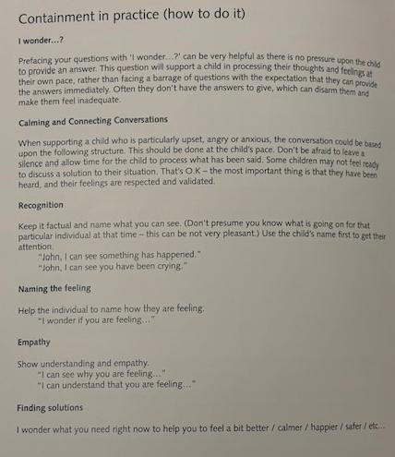
It is the responsibility of all adults to implement the school behaviour policy consistently throughout the school. Adults should not act upon the information until all areas of the investigation have been explored. It is the responsibility of the Head Teacher to report upon the effectiveness of the Behaviour Policy as requested.

Parents will
- Understand that everything we say and do is underpinned by the values that Jesus taught us, and we are learning to live them out on a daily basis

- Support their child in adhering to the school rules and the expectations of good behaviour
- Ensure that their child fully understands the school rules and the consequences of not adhering to them
- Support their child by ensuring their child attends school regularly and arrive promptly
- Inform the class teacher of any changes in circumstances which may affect their child’s behaviour
- Discuss any concerns with the class teacher promptly

Governors will
- Promote the Christian ethos of St. Edward’s School where all are equally valued as members of the school community
- Creating an effective partnership between pupils, parents’ staff and governors
- Maintaining a caring, safe and nurturing environment where pupils can flourish
- Developing a positive reputation in the community
- Ensuring that the school community is safeguarded

Prevent Duty
The school fulfils its duties under the Prevent Duty by challenging extremist language, hate‑based attitudes and behaviours that may indicate a risk of radicalisation. Staff are trained to recognise early signs of concern and report these immediately to the Designated Safeguarding Lead. The DSL will assess the level of risk and, where appropriate, engage external agencies to ensure that pupils are safeguarded from extremist influence.

Children with Special Educational Needs:
Please note that some children fall outside this Behaviour Policy. Such children may be given a Strategy Plan for behaviour and support may be obtained from SEMH (Social, Emotional and Mental Health specialists. A specific plan may be drawn up with individualised rewards and sanctions in conjunction with child, parent, school and support service if appropriate.

The school recognises that behaviour may be an indicator of underlying mental health needs. Staff are trained to identify changes in behaviour that may signal emotional distress or emerging mental health difficulties. Concerns are escalated to the SENCO or Designated Safeguarding Lead, and pupils may receive pastoral support, SEMH interventions, counselling or referral to external agencies. The school works closely with families to ensure that pupils receive the right support at the right time.

Rewards
It is our firm belief that children naturally respond to praise and encouragement and want to please their significant adults such as parents/carers/teachers. Praise creates a positive self-image in a child, not only helping them to feel good about themselves, but also empowering them with self-belief and confidence and encouraging them to treat others in a similar fashion. After parents/carers, the next greatest influence upon a young child is the teacher. Rewards are most effective if they follow immediately upon the desired behaviour. As the child grows older peer praise gains greatly in significance and this is encouraged, taught and modelled in school.
Rewards are built into the daily routine of school life and include:
- Regular verbal praise from all staff - for good work and good behaviour
- A class charter discussed and agreed by each class
- Class “Gems” awarded for achievement in class and around school where pupils put into practice our school be-attitudes.
- Head Teacher stickers awarded for high quality work/effort and/or behaviour by a child, group or whole class
- Friday celebration assembly award pupils who have:
  - demonstrated the “Be-attitudes” in all they have said and done
  - tried their best in English and maths and in the overall curriculum
  - achieved in an activity they have attended either in school or outside.
- Pupil of the term – selected by Governor from a list presented by class teachers. This award, and trophy, is presented 3 times per year at our end of term assembly.

Sanctions
At St Edward’s we make every effort to ensure that sanctions are applied calmly, fairly, firmly and consistently. Quiet, calm reprimands are often more effective than public ones, although we recognise the need to ensure that the child in question does not find the individual attention rewarding rather than punitive.
We at St Edward’s acknowledge that there are degrees of inappropriate behaviour and therefore degrees of responses. The whole school community bears responsibility for the behaviour of every child, and as such will adhere to the “Home School Agreement”.

All pupils contributed to devising our “Restorative Justice” questions and responses. These are displayed within each class coupled with a designated “Zone of Regulation”. Children are encouraged to complete a reflection page when they have not adhered to the school “Be-attitudes” and are supported by staff to do this.

The school may apply sanctions for behaviour that occurs outside the school premises when such behaviour has a clear link to school life or affects the welfare of pupils or staff. This includes behaviour on school transport, during school trips or visits, in the community, or online. Where behaviour outside school poses a safeguarding concern, the matter will be referred to the Designated Safeguarding Lead in accordance with statutory guidance.

Use of Reflection

Prior to a child is given time in reflection adults should.
- Encourage the child to use the calming corner in class to deescalate the situation
- Use the resources within the calming corner to support them to regulate their emotions
- Spend some time with the pupil to establish why low-level disruption may be happening during lesson time. This works on the Solihull Approach model of rupture and repair (appendix 1) and supports the adult to build a positive relationship with the child, which is crucial if the behaviour is to improve and move forward.
- Class teachers should discuss with the child the behaviour and gain the child’s view on how long they feel they should spend time in reflection. Class teachers should support the child in the reflection time matching the severity of the incident.

Consequence | Levels / examples of behaviour concerns | Parent communication
Step 1  Up to 15 minutes | - Repeated disruption in class  - Not following the school rules in class or around school  - Not following adult instructions | Spoken to by the class teacher
Step 2  Up to 30 minutes | - Physically hurting another child / adult  - Verbal abuse towards another child / adult  - Swearing | Spoken to by Class Teacher or Family Support Worker
Step 3  Up to a whole lunchtime | - Extreme unsafe behaviour  - Persistently verbally abusing another child / adult  - Persistently physically hurting another child / adult  - Incidents of bullying (refer to anti-bullying policy) | Spoken to by Head of School due to the serious level of  concerns.

Behaviour Logs / Chart
A behaviour log will be introduced when a child has been in reflection on more than three occasions in one week. Parents will be invited in to speak with the class teacher to share concerns and implement the behaviour log to ensure home and school are working together to improve a pupil’s behaviour. The behaviour log will be completed each day by the class teacher and will be in place for a two-week period. All behaviours (from any stage) will be logged each day. When a behaviour log has been introduced the child will be included in the process by having a behaviour chart in class to support them in sharing their views on their behaviour and will be asked for their opinion (there will be different behaviour charts for each Key Stage). This will be reviewed with parents at the end of the second week. At this review meeting it will be decided if the behaviour log should be extended or closed, the rationale for this decision would be shared during this meeting. However, should a Stage 2 or 3 incident occur while the child is on a behaviour plan, then parents will be informed immediately, and the school will consider whether an internal exclusion is the next appropriate consequence.
If the behaviour log and chart have little or no impact on the pupil’s behaviour, then during a review meeting it would be discussed to move to a more formal behaviour support plan.

The school systematically records and monitors behaviour incidents, including discriminatory behaviour, child‑on‑child abuse, physical intervention and suspensions. Senior leaders analyse behaviour data to identify patterns, vulnerable groups, emerging concerns and the impact of interventions. This analysis informs strategic decision‑making and is shared with governors to support their oversight of behaviour, safeguarding and equality duties.

Inclusion
The inclusion of all children of any race, or disability whose special needs we are able to be meet and give appropriate access to the curriculum, is the heart of our foundation. To this end we:
- regularly address appropriate curricular provision through audit and subsequent revised provision to meet the needs of our children
- work with outside agencies to effectively inform staff about individual and group needs
- secure appropriate resources for all properly identified needs

- make real and sustained efforts to enlist support and establish partnership with all parents recognising the needs of the marginalised
- regularly review the effects of behaviour strategies and induct staff into their use
- use key stage and LTS meetings to regularly discuss concerns, lift awareness and build staff confidence and expertise in dealing with different and challenging children
- play situations appropriately resourced and used to extend socialisation and positive interaction and independent self-management for all children

Suspension and Exclusion
Suspension and exclusion are an extreme measure, and every step should be taken through the code of practice and application of strategies and sanctions to avoid suspension and exclusion in line with our Suspension and Exclusion Policy.

Individual Behaviour Plans/Special Arrangements
In cases where individual children experience difficulty in behaving as we would wish them to, and little progress in modifying their behaviour is noted following the consistent use of the school’s normal range of rewards and sanctions, the child will need to be discussed with SENCO and parents and consideration given for inclusion on the school’s special educational needs register if appropriate.

If this is the case, the child’s teacher will discuss the child with the Senior Leadership team and the SENDCo, who will provide advice and support in drawing up and the implementation of appropriate plans or arrangements. This is usually undertaken in liaison with the child’s parents/carers and with their support.

The use of reasonable force to control and restrain pupils
Following the issue of draft guidance from the DCSF these are the very limited circumstances in which the use of restraint is appropriate.
- where a pupil’s behaviour is at risk of causing injury to him/her self.
- where a pupil’s behaviour is likely to cause injury to others (adults or children).
- where a pupil’s behaviour is likely to cause serious risk of damage to property.

The school follows the statutory requirements relating to physical intervention, restraint and seclusion. Physical intervention is used only when necessary to prevent immediate risk of harm to a pupil or others, and always in a proportionate manner. Restraint is used only as a last resort and by trained staff. Seclusion, defined as supervising a pupil alone in a room they cannot leave, is used only to prevent immediate harm and never as a punishment. Any use of seclusion must be time‑limited, continuously monitored, and recorded. Parents are informed of all incidents involving restraint or seclusion, and senior leaders review each incident to ensure that practice remains safe, lawful and appropriate. Governors receive oversight reports as part of their safeguarding responsibilities.

Pupil transition
To ensure a smooth transition to the next year, children have transition sessions with their new teacher(s). In addition, staff members hold transition meetings. With in year transition the school rules and behaviour expectations will be shared with the pupil. The behaviour policy is a document within the school’s induction pack that is shared with parents prior to starting at the school.
To ensure behaviour is continually monitored and the right support is in place, information related to behaviour issues may be transferred to relevant staff at the start of the term or year. Information on behaviour issues may also be shared with new settings for those children transferring to other schools.

Racist Incidents
It is a requirement that any incident with racist overtones must be recorded as a racist incident and immediately reported to the Head Teacher, with details noted down so that official recording can be made and appropriate action taken this would age/developmentally appropriate. All racial incidents are recorded on Bromcom

In addition to racist incidents, the school records and responds to all forms of discriminatory behaviour, including homophobic, biphobic, transphobic, sexist, misogynistic, ableist and faith‑targeted language or actions. These behaviours are unacceptable and are treated as serious breaches of the school’s expectations. All discriminatory incidents are recorded on Bromcom and monitored by senior leaders to identify patterns or disproportionate impact on particular groups. Parents are informed of such incidents, and restorative work is undertaken with all pupils involved to ensure understanding, accountability and reconciliation.

Definition of a racist incident
Our definition of racial incidents is that of the CRE (Commission for Racial Equality):
Verbal or physical violence which includes attacks on property as well as on the person, which is suffered by individuals or groups because of their colour, race, nationality and ethnic or national origins, and where the victim believes that the perpetrator was acting on racial grounds and/or there is evidence of racism.
A racist incident may include:

- Derogatory name-calling, insults, racist jokes and language
- Verbal abuse and threats
- Physical assaults
- Ridicule based on differences of colour, race, ethnicity, nationality, culture, religion or language
- Refusal to co-operate with others because of any of the above differences
- Stereotyping based on colour, race, ethnicity, etc.
- Racist comments
- Racist graffiti
- Written abuse
- Damage to property
- Provocative behaviour such as wearing racist badges or insignia' (Please note this list is not exhaustive)

Appendix 1

The Solihull Approach (for further information please refer to the Solihull Approach training manual which j_�JQ.G_§t�.d.in the FSW office)

lniti tion

Peak of excitement
The Dance of Reciprocity is the basis for all healthy relationship. A degree ofmismatching is necessary to promote healthy emotional growth and to facilitate resilience. Rupture and Repair" is a stage of the Dance of Reciprocity when the child processes the interaction during the withdrawal / look away stage. This leads to learning.

UNDERSTANDING YOUR CHILD
CJ ._. -,:.------

5OLI HULL APPROACH

Rupture and repair
  - Getting out of step in the dance (RUPTURE) but adjusting to get back into step (REPAIR)= Normal
  - We experience that things can still get back on track
•
Repeated rupture WITH
repair
Repeated rupture WITHOUT
repair

Develop hope, optimism, belief things get better, self esteem, self worth, trust in others
Good quality relationships

Don't develop self worth, self esteem or trust in others
? Quality of relationships

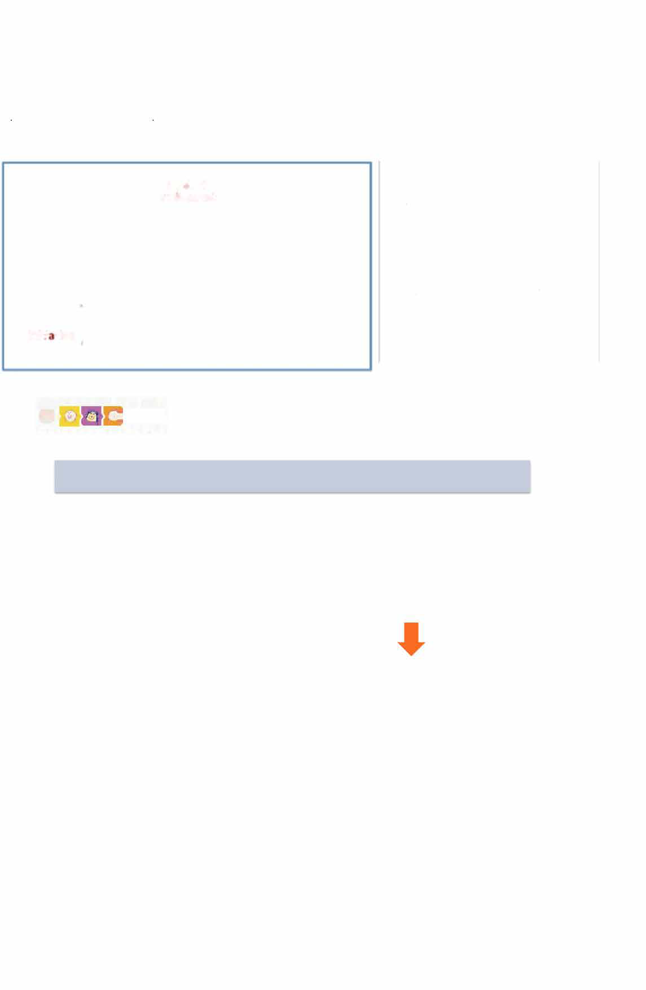
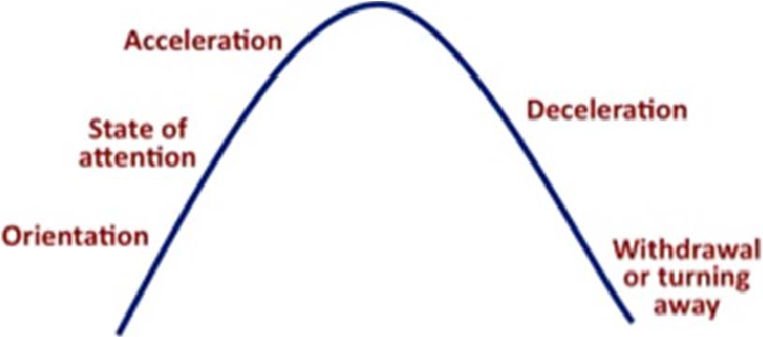
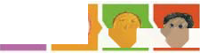

9

Appendix 2

At St Edward’s we follow the “Be – attitudes” and therefore our school rules encourage us to be the best we can be!
are:


St Edward’s Pledge

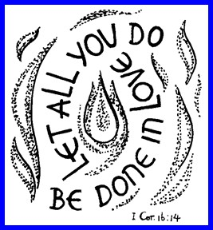

“Our Be – Attitudes”

As pupils of St Edward’s, we are committed to being
“ The Best We Can Be “
– in our attitude towards behaviour and in our learning.

We promise to follow our school rules:
- Be Kind
- Be Polite
- Be Honest
- Be Helpful
- Be a Friend
- Be the best I can be

Appendix 3

Name:
Date:
What did I do?

Why did I do this?

I was feeling?

“Let All We Do Be Done in Love”
Reflection Sheet (EYFS / KS1)
Write or draw a picture

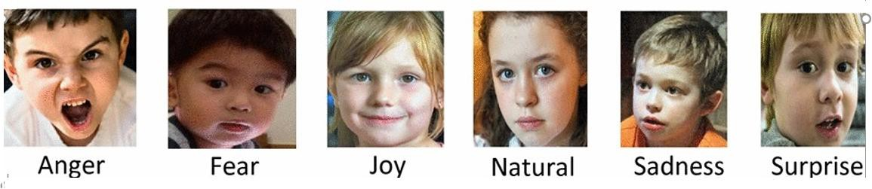
What will I do next time?

Staff Name and signature………………………………………………………………………………………… Pupil signature………………………………………………………………………………………………………….

Appendix 4

Name:

Date:

What did I do?

Why did I do this?

I was feeling?

“Let All We Do Be Done in Love”
Reflection Sheet (KS2)

What will I do next time?

Staff Name and signature………………………………………………………………………………………… Pupil signature…………………………………………………………………………………………………………

Appendix 5
Weekly Behaviour Log
Name: Class:

Date and time | Location | Incident and resulting behaviour | Parents  Informed
 |  |  | Y or N
 |  |  | Y or N
 |  |  | Y or N
 |  |  | Y or N
 |  |  | Y or N
 |  |  | Y or N

Appendix 6 – Pupil Behaviour Chart (Scale 0-5 Unacceptable to Excellent)

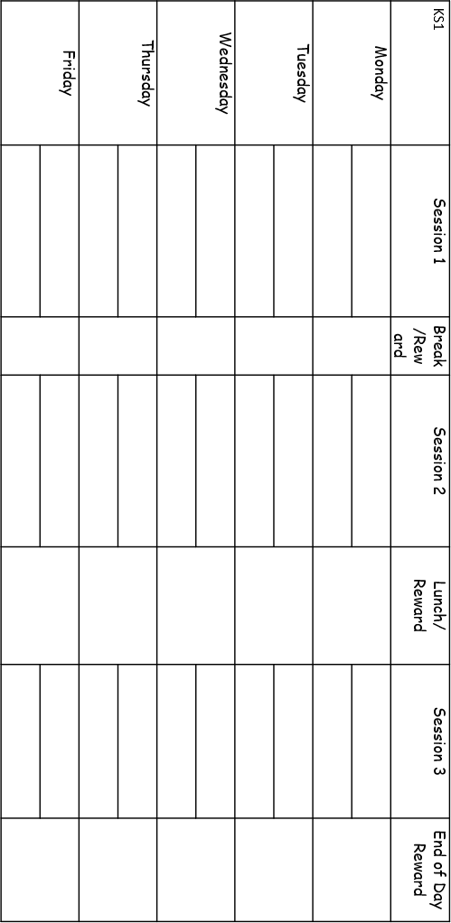


KS2 Session 1 Break Session 2 Lunch Session 3 End of Day Monday
15
Tuesday

Wednesday

Thursday

Friday

